Project Name: **Payroll Generation Application**:

**Specifications and Inputs :**

**Inputs for the Building the application is :**

Number of Hours worked per week.

Wages Per Hour

Tax Percentage=20%

**Specifications:**

Based on above inputs ,Need to generate the below outputs as part of Weekly Salary Report.

Build Button with Name Weekly Salary and as soon as we click on this we need to generate for below.

GROSS Pay

Net Pay

Over Time Hours

Apart from above Specifications,

Build Functionality for Resetting the values to blank Using RESET Button.

Generate Payslip Report using View PaySlip button.

**Application Prototype should be as given below:**

**Before Providing inputs:**

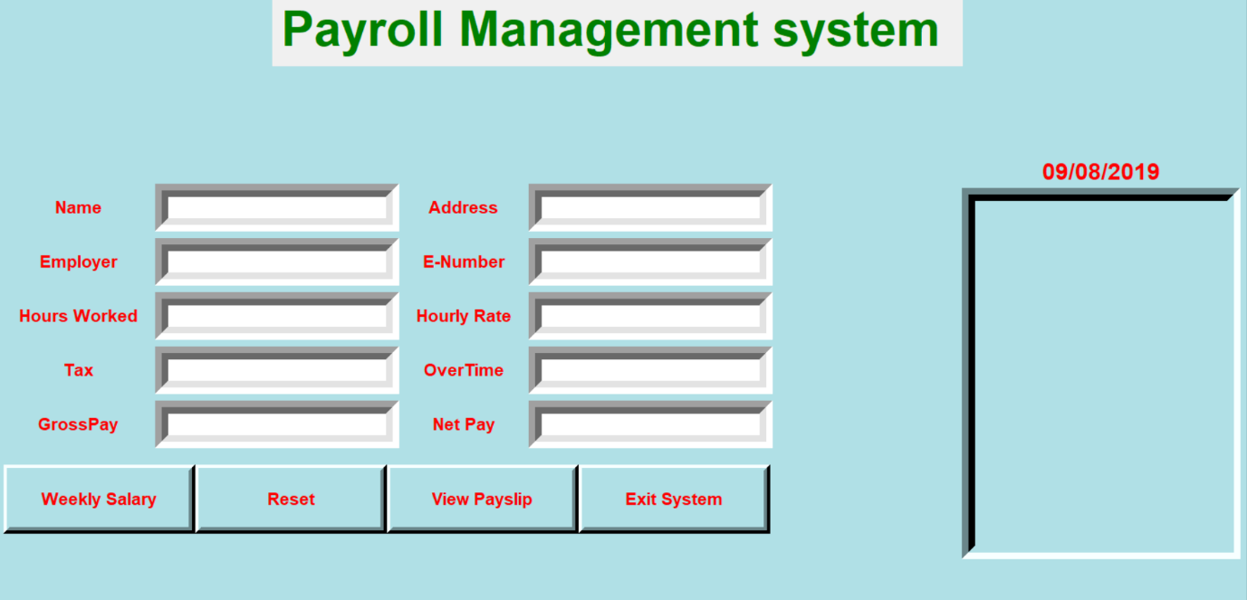

After Provding inputs :

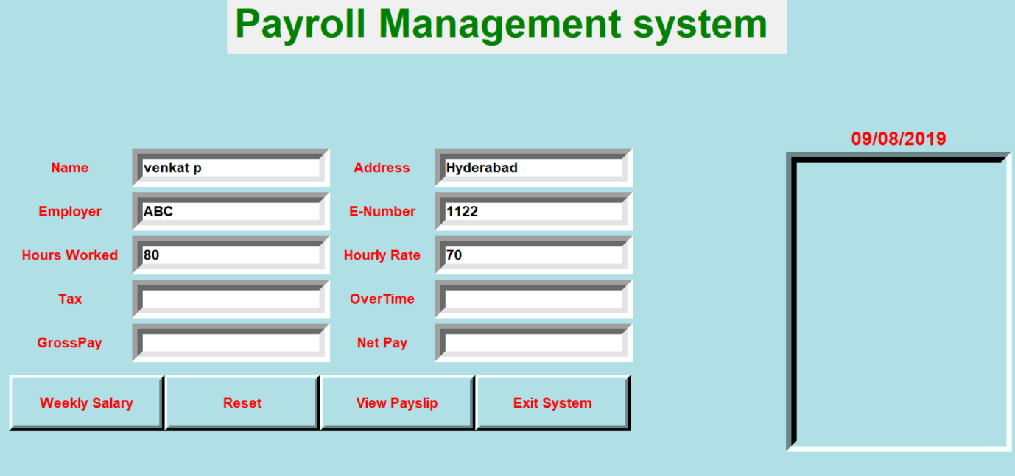

Click on Weekly Salary:

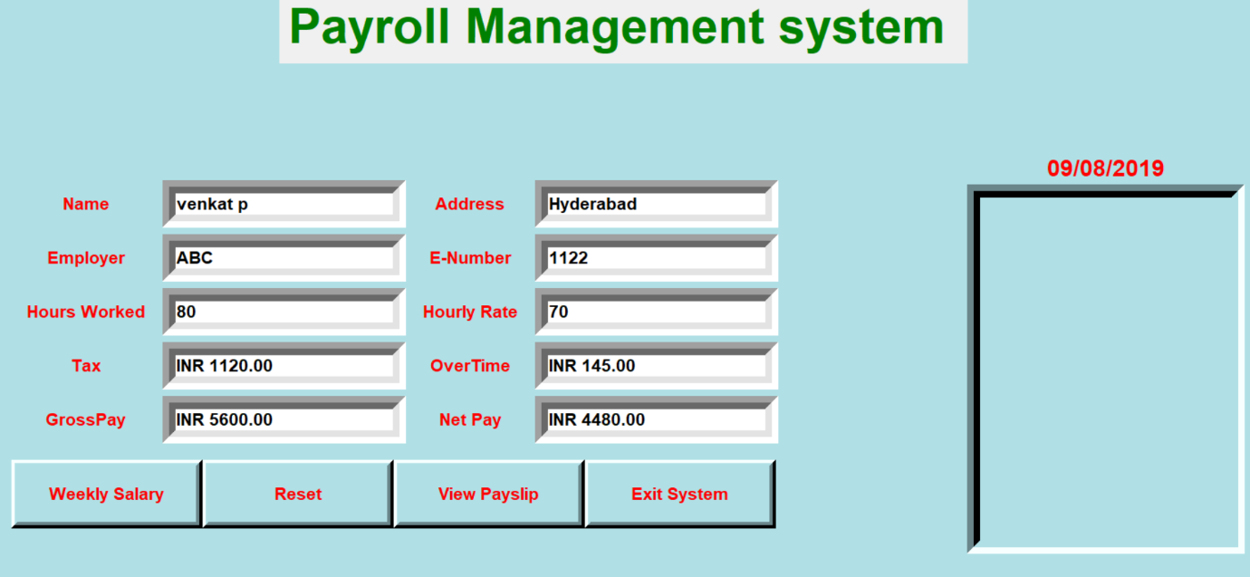

Reset:



View Payslip:

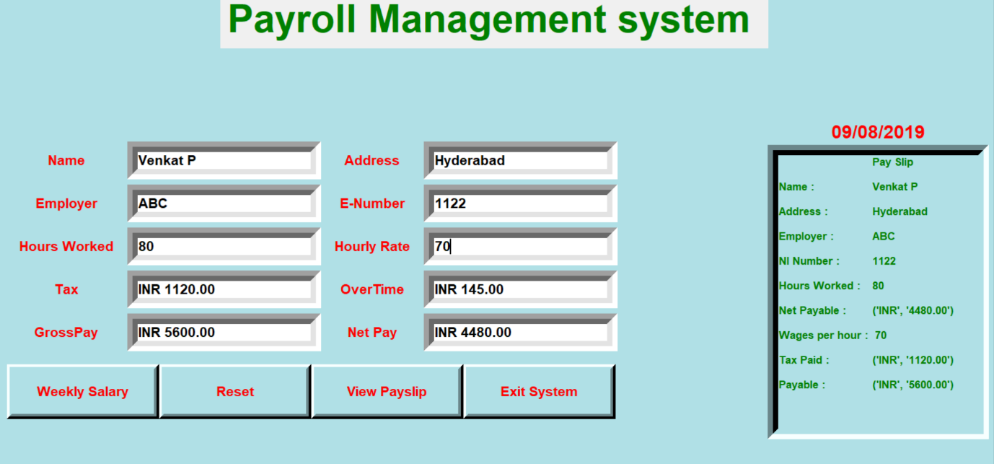

Exit:

